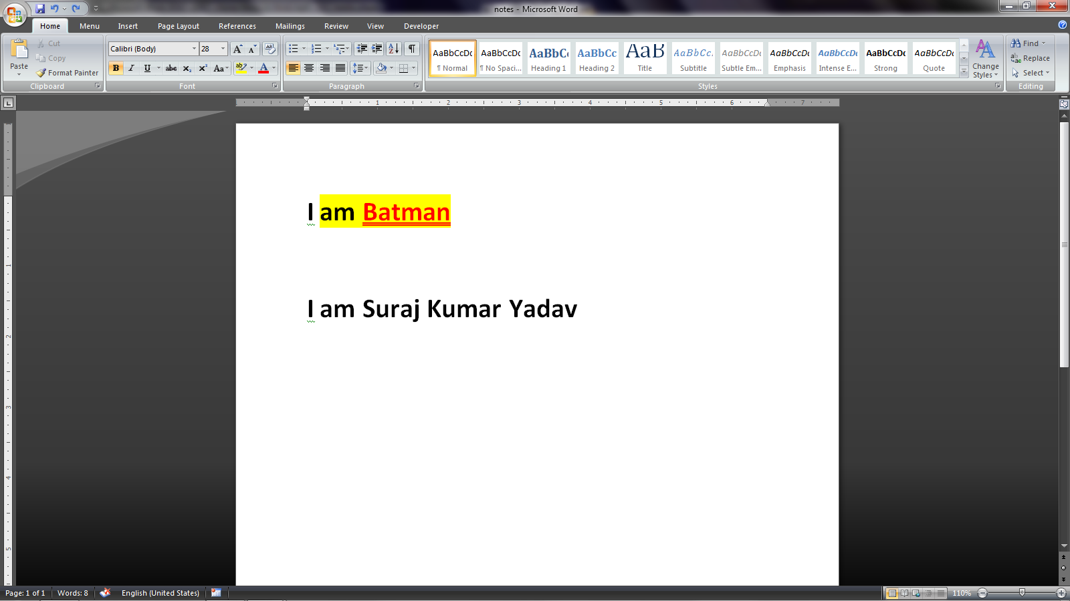if we have to apply all effects of “Batman” on below text “I am Suraj Kumar Yadav”
Firstly select the word “Batman” and then click on “Format Painter” 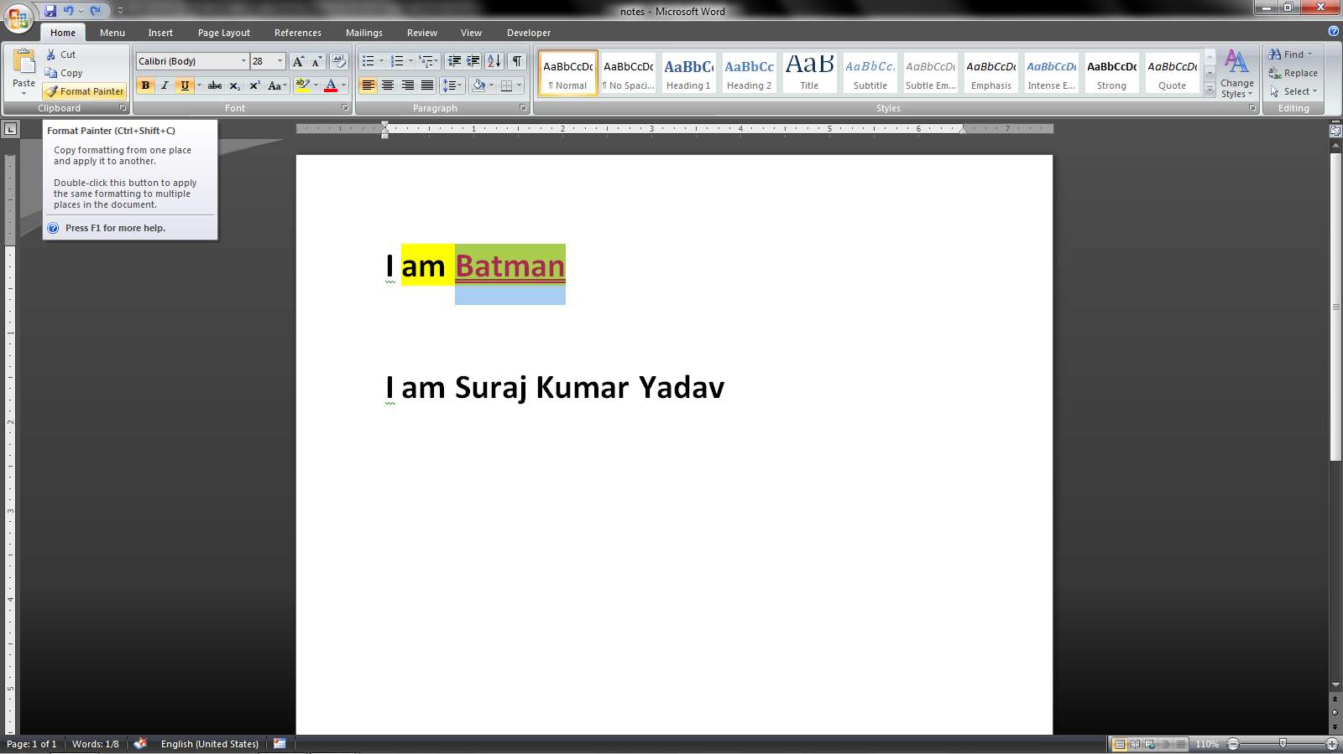then select the word/sentence to which we want to apply the effect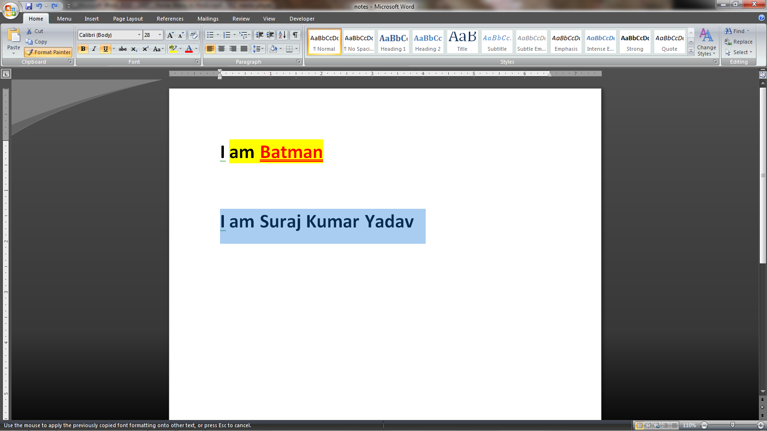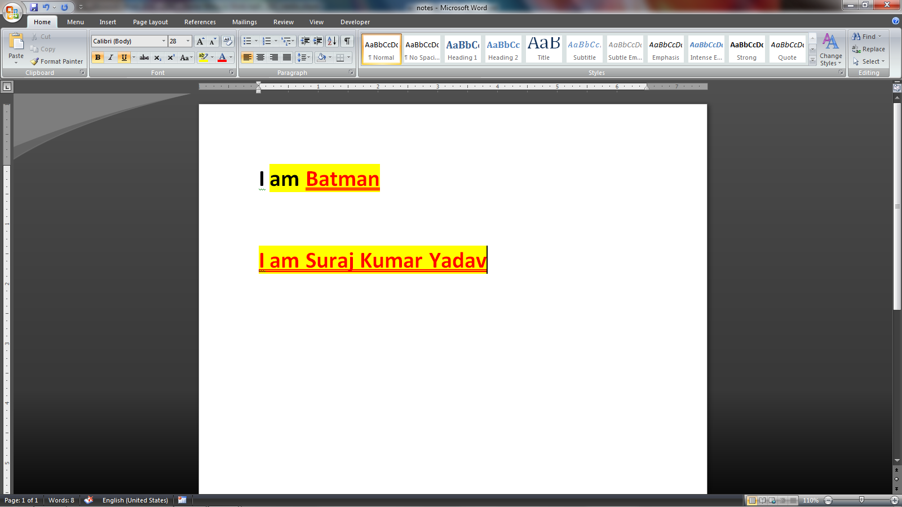
To clear all formatting select the given text and click on “Clear Formatting” icon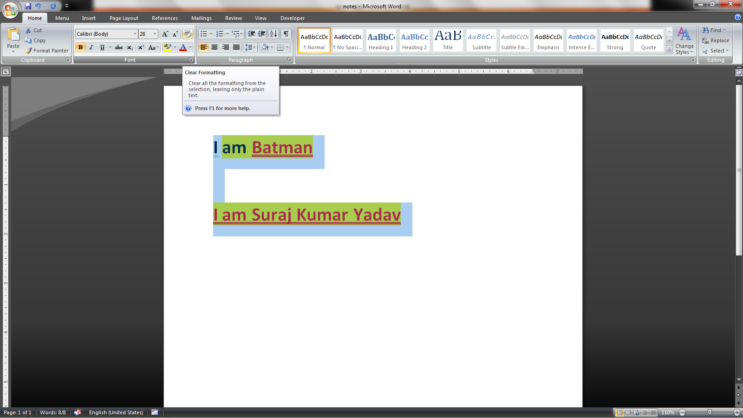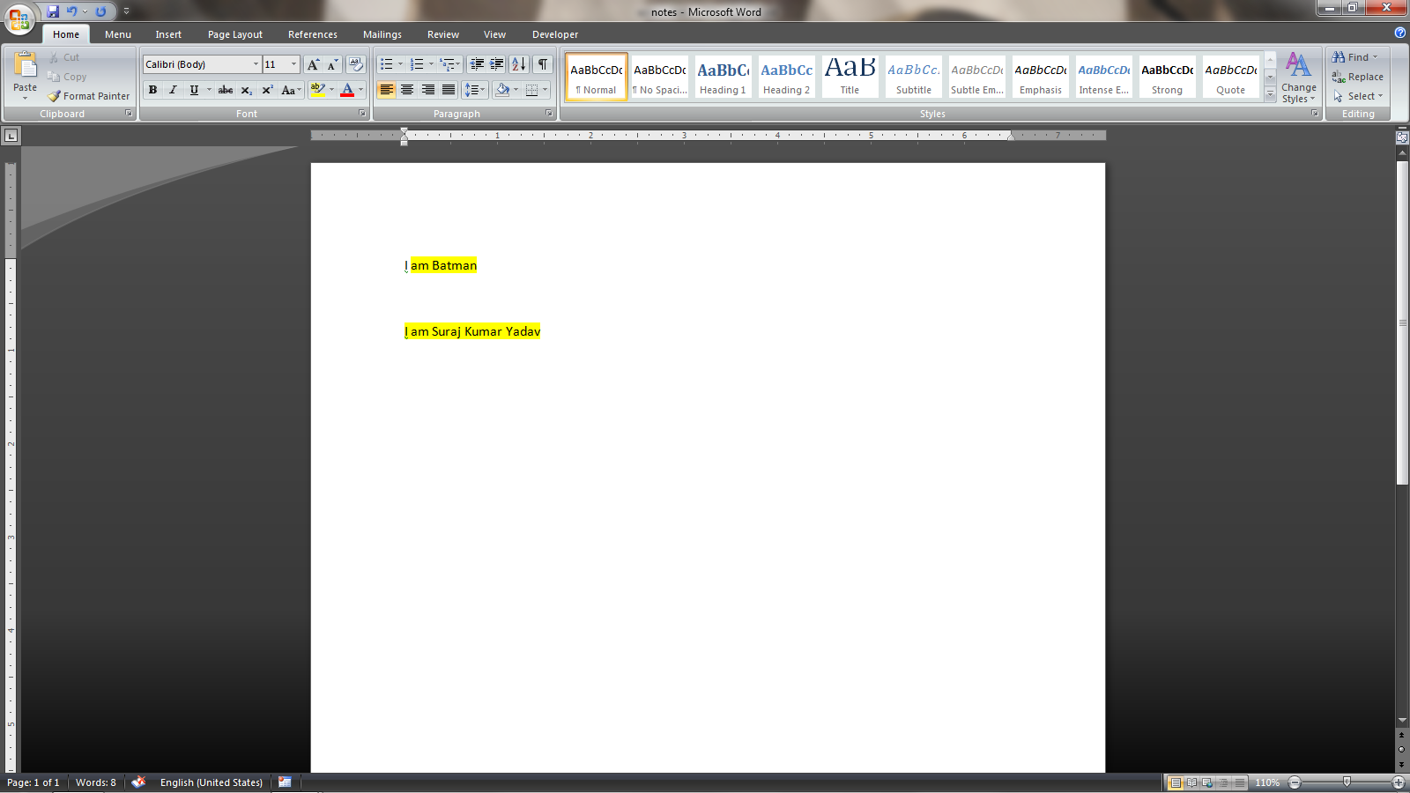But it will not remove the “Text Highlighted Color” so we have to do it manually